

Winners and Losers of Globalisation

AGENDA & SPEAKERS’ BIOS

Collegio Carlo Alberto, Torino
14-15 November 2017



Winners and losers of globalisation

Collegio Carlo Alberto
Torino, 14-15 November 2017

Vision Europe is a consortium of think tanks and foundations, launched in 2015, collaborating to address some of the most pressing public policy challenges facing Europe and its member states. Through research, publications and an annual summit, we aim to be a forum for debate and a source of recommendations to improve evidence-based policy-making at both national and EU level and to foster an appropriate European integration. Over the course of the past two years we addressed the pressing issues of the future of the welfare state as well as migration and refugee flows.

For their 2017 common effort, the Vision Europe partners chose to address the ghost that in the last few years – at least following the great financial crisis of 2008, – has been haunting Europe, and the whole world: globalisation itself. More precisely, we decided to deal with the all-encompassing question of “winners and losers of globalisation”. Our goal, in tackling such a controversial issue, was to go beyond taking stock of the impact of globalisation on economic, political and social systems around the world, and, consistently with the main aim Vision Europe has pursued since it was launched three years ago, to make policy recommendations based on sound scientific analysis.

At the summit, stakeholders drawn from politics, business, civil society and academia will have the opportunity to discuss such recommendations. A conference declaration expressing principles and proposals to make open societies and open economies sustainable will be finalized at the summit.

More information about the consortium and the summit can be found on our website: www.vision-europe-summit.eu

14 November
Auditorium
02:00 p.m. | Welcome Address and Introduction  Francesco Profumo, Chair, Compagnia di San Paolo, Turin  Pietro Terna, President, Collegio Carlo Alberto, Turin
02:15 p.m. | Setting the Scene: An Economic Perspective  Quentin Peel (chair), Associate Fellow, Chatham House, London  Michael Spence, Professor of Economics, New York University
02:45 p.m. | Plenary Debate based on Vision Europe Policy Briefs  “Trade, Democracy and Institutions: Rethinking Globalisation”  Elvire Fabry (chair), Senior Research Fellow, Jacques Delors Institute, Paris  Thieß Petersen, Senior Advisor, Bertelsmann Stiftung, Gütersloh  Maurizio Ferrera, Professor of Social Policy, University of Milan  Grégory Claeys, Research Fellow, Bruegel, Brussels  Christopher A. Hartwell, President, CASE – Center for Social and Economic Research, Warsaw  Thomas Raines, Research Fellow and Program Manager Europe Programme, Chatham House, London  Yves Bertoncini, Consultant in European Affairs and President of the European Movement, France
04:00 p.m. | Coffee Break
04:30 p.m. | Parallel Discussions  Globalisation: Challenges and Responses  Discussion I: How Can we Make Globalisation More Inclusive? (Auditorium)  Iulia Siedschlag (Chair), Associated Research Professor Economic and Social Research Institute, Trinity College, Dublin  Chiara Saraceno, Honorary Fellow, Collegio Carlo Alberto, Turin  Martin Daunton, Emeritus Professor of Economic History, University of Cambridge  Peter Scherrer, Deputy General Secretary, European Trade Union Confederation, Brussels  Discussion II: Can Globalisation be Democratic? (Aula Lignea)  Marco Lisi (chair), Professor, New University of Lisbon  Alan Beattie, International Economy Editor, Financial Time, London  Aura Salla, Adviser for Communication and Outreach, European Political Strategy Centre, European Commission, Brussels  Ugo Mattei, Professor University of Turin and University of California, Hastings College of the Law  Discussion III: Is the Era of Deepening Globalisation Coming to an End? (Classroom 2)  Linda Zeilina (chair), Advisor and Head of Future Europe Program Re-Define, London  András Inotai, Research Professor, Institute of World Economics, Centre for Economic and Regional Studies, Hungarian Academy of Sciences Research, Budapest  Nauro Campos, Professor of Economics and Finance, Brunel University, London  Mario Deaglio, Emeritus Professor of International Economics, University of Turin
06:00 p.m. | End of Discussion
07:30 p.m. | Cocktail and Keynote Speech: Globalisation and Human Rights  Isabel Mota (chair), President, Calouste Gulbenkian Foundation, Lisbon  Denis Mukwege, Mukwege Foundation, Switzerland

15 November
Auditorium
09:00 a.m. | The Next Era: a new Nordic Societal Vision for Well-Being  Aleksi Neuvonen, Demos Helsinki
09:30 a.m. | Plenary Debate: Beyond the European Perspective  Piero Gastaldo (chair), Secretary General, Compagnia di San Paolo, Turin  Peter H. Chase, Senior Fellow, German Marshall Fund of the United States  Salam Kawakibi, Deputy Director for the Arab Reform Initiative  Liepollo Lebohang Pheko, Senior Research Fellow at Trade Collective, Africa, Coordinator of the INMD, Member of the Action Research Network for WE-Africa, South Africa  Karl Brauner, Deputy Director-General, World Trade Organization
10:45 a.m. | Conversation: The Future of Global Trade  Guntram Wolff (chair), Director, Bruegel, Brussels  Marion Jansen, Chief Economist, International Trade Centre, Geneva
11:15 a.m. | Coffee Break
11:45 a.m. | Plenary Debate: The Role of EU Policy in Preventing the Negative Impacts of Globalisation  Stefano Sacchi (chair), University of Milan and President, National Institute for the Analysis of Public Policies (INAPP), Rome  Joost Korte, Deputy Director-General, European Commission DG Trade  Bernadette Ségol, Former Secretary General of the European Trade Union Confederation, Brussels  Stefan Profit, Deputy Director-General Macroeconomic Development, Analysis and Projections, Federal Ministry for Economic Affairs and Energy, Berlin
12:45 a.m. | Presentation and Discussion of the Summit Declaration  Adam Ward, Deputy Director, Chatham House, London  Aart de Geus, Chairman and CEO, Bertelsmann Stiftung, Gütersloh
1:15 p.m. | Closing Remarks

Speakers’ bios

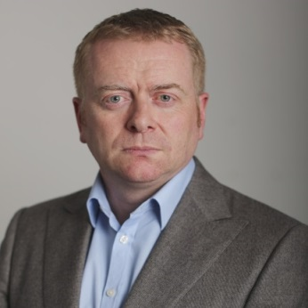
Alan Beattie
International Economy Editor, Financial Time, London

Alan Beattie is the European leader writer for the Financial Times. Based in Brussels, he comments on a wide range of issues, focusing on economics and trade. Previously he was the FT's international economy editor, based in Washington. Before joining the FT in 1998, Mr Beattie was an economist at the Bank of England.

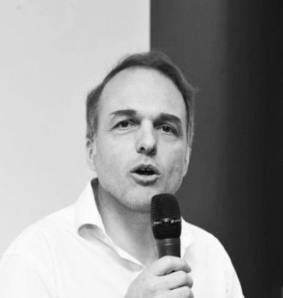
Yves Bertoncini
Consultant in European Affairs and President of the European Movement, France

Yves Bertoncini is an Expert and Consultant on EU affairs.
He teaches European issues at the Corps des Mines (Mines Paris Tech) and at the College of Europe in Bruges. He is President of the Mouvement Européen-France since December 2016.
He has been director of the Jacques Delors Institute between April 2011 and September 2017. He advised and assisted the presidents of the JDI in their activities, managed the team and was responsible for implementing the work programme. He also took part in the JDI’s research work, focusing in particular on questions of European politics and institutions and on issues relating to democracy and mobility.
Yves Bertoncini is an administrator at the European Commission, where he has worked at the Directorates-General “Education, Training, Youth” and “Regional Policy”.
He has worked in the office of the French prime minister with responsibility for research on Europe at the Centre d’Analyse Stratégique/France Stratégie (2006-09), and as adviser to the Secretary general of European affairs (2010-11). He has also worked for the French ministry of foreign and European affairs, on the organisation of the “national dialogue for Europe” (1995-97) and at the French embassy in Algiers (1992-93). He was Head of international affairs at the French Insurance Association (2002-05) and Director of studies at the Conseil de Coopération Economique (2005-06).
He teaches or has taught European issues at the Corps des Mines (Mines Paris Tech - since 2007), at the College of Europe in Bruges (since 2016), at the Institut d’Études Politiques (IEP) in Paris (2001-11) and at the École Nationale d’Administration (2007-09). He is the author of numerous books articles and policy papers on European questions.
Yves Bertoncini holds degrees from the Institut d’Études Politiques in Grenoble and the College of Europe in Bruges. He has also studied at the Sciences Po Paris and at the University of California in Berkeley.
He was born on 30 March 1970 in Chambéry and is married with three children.

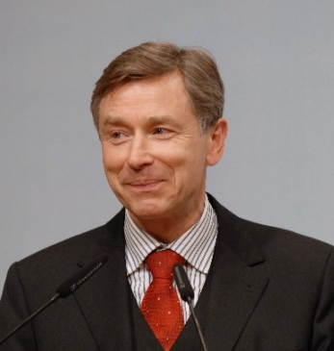
Karl Brauner
Deputy Director-General, World Trade Organization

Karl Brauner has been Deputy Director-General of the WTO since 2013. Prior to that, he held the position of Director General for external economic policy in the German Federal Ministry of Economics in Berlin. During that time, he was Germany’s member in the European Union’s Trade Policy Committee taking part in all WTO ministerial conferences since the launch of the Doha Development Agenda.
He is a lawyer by profession, with degrees from Germany and the United Kingdom (Cambridge). After working as Assistant Professor at the University of Bielefeld and practising law, he started his career in the legal department of the Federal Ministry of Economics in Bonn in 1983. In 1986-87, he worked at the German Mission to the United Nations in New York. Further postings abroad were in Athens and Sydney.
At the Ministry of Economics in Berlin, his responsibilities covered a range of issues, such as budget, human resources and general administration. He was in charge of cabinet and parliamentary matters and was also involved in the move of the Government from Bonn to Berlin.
As Director General he administered for 12 years all the instruments of export promotion and was also in charge of export controls. His portfolio also comprised all bilateral economic relations outside the EU.

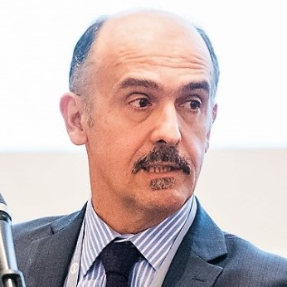
Nauro Campos
Professor of Economics and Finance, Brunel University, London

Nauro F Campos is Professor of Economics at Brunel University London and Research Professor at ETH Zurich. His main fields of interest are political economy and European integration. He is also a Professorial Fellow at UNU-MERIT (Maastricht University), a Research Fellow at IZA-Bonn, a Fellow of the Global Labor Organization, a member of the Scientific Advisory Board of the Bank of Finland, and a Senior Fellow of the ESRC Peer Review College. Previously he was a Fulbright Fellow at Johns Hopkins University, a McNamara Fellow at The World Bank, a CBS Fellow at University of Oxford, and a visiting professor at Sorbonne and Warwick. From 2009 to 2014, he was seconded as Senior Economic Advisor to the Chief Economist of the UK’s Department for International Development. He received his Ph.D. from the University of Southern California (Los Angeles) in 1997.

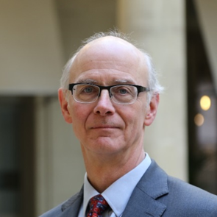
Peter Chase
Transatlantic Fellow, German Marshall Fund, Brussels

Peter Chase is currently a Transatlantic Fellow with the German Marshall Fund in Brussels. He recently left the U.S. Chamber of Commerce after six years as its Senior Representative in Europe, based in Brussels; he was Vice President for Europe between July 2012 and his departure in February 2016. After joining the Chamber in April 2010, Mr. Chase played a critical role in the Chamber’s campaign to launch U.S.-EU negotiations toward an ambitious free trade agreement, including funding an initial study to demonstrate the benefits of merely eliminating tariffs and helping convince the European business community to support the effort; this led to the formal launch of the Transatlantic Trade and Investment Partnership (TTIP) talks in July 2013. Mr. Chase is widely recognized for his expertise on virtually all aspects of the proposed agreement, including in particular the regulatory and investment issues. He has also led much of the Chamber’s work in Europe on energy, capital markets regulation, digital policy issues and EU economic relations with third countries, notably China and Russia. Prior to joining the Chamber, Mr. Chase had more than 30 years of economic, trade and investment policy experience in the U.S. Department of State. The last 20 years focused largely on transatlantic economic relations. He was Minister-Counselor for Economic Affairs at the U.S. Mission to the European Union (USEU) from 2007-2010; Director of the Office of EU Affairs at the State Department 2004-2007; Chief of Staff to the Under Secretary for Economic Affairs 2001-2003; Counselor and Minister-Counselor for Economic Affairs at the U.S. Embassy in London 1997-2001; and Financial Officer and Counselor for Economic Affairs at USEU 1992-1996. Prior to this last assignment, Mr. Chase was posted for two years as Director for Investment Affairs at the Office of the U.S. Trade Representative from 1990-1992; he also served between 1988 and 1990 as Legislative Assistant for Economic and Foreign Policy Affairs with Senator Bill Bradley (D-NJ). The majority of his early diplomatic career, in contrast, focused on China, with assignments to Canton in 1980, the China desk in 1984-1986, and a secondment to Taiwan from 1986 to 1988. Mr. Chase, who grew up in Taiwan, received his Bachelor of Arts in Chinese Language and Literature from the University of Washington in Seattle in 1976 and his Master of International Affairs from Columbia University in 1978. He was married and has three grown daughters.

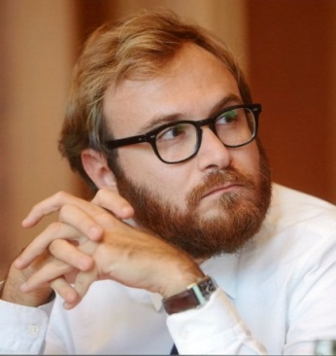
Gregory Claeys
Research Fellow, Bruegel, Brussels

Grégory Claeys has been a research fellow at Bruegel since 2014 and an associate professor at the Conservatoire National des Arts et Métiers in Paris where he teaches macroeconomics since 2015. His research interests include international macroeconomics and finance, central banking and European economic governance. Prior to joining Bruegel, he conducted research in several capacities, as a visiting researcher in the Financial Research Department of the Central Bank of Chile in Santiago, and as an economist in the Research Department of the French bank Crédit Agricole in Paris. He holds a PhD in Economics from the European University Institute (Florence), an MSc in economics from Paris X University and an MSc in management from HEC Paris.

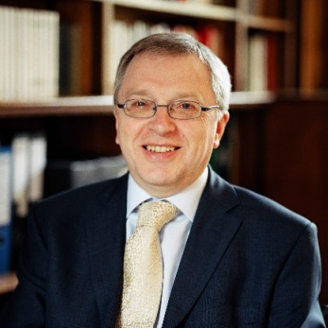
Martin Daunton
Emeritus Professor of Economic History, University of Cambridge

Martin Daunton was Professor of Economic HIstory at the University of Cambridge from 1997 to his retirement in 2015. Pior to that, he was Astor Professor of British HIstory at UCL. He has also been Master of Trinity Hall in Cambridge from 2004 to 2014, and was twice Head of the School of the Humanities and Social Sciences, as well as serving as President of the Royal Historical Society. He has written extensively on the history of taxation and public finance, including Tursting Leviathan: The POlitics of Taxation in Bitain 1799-1914 (Cambridge 2000) and Just Taxes: The POlitics of Taxation in Britain, 1914-1979 (2001). He recently co-edited a volume on The POlitics of Public Finance since 1973 (Cambridge 2017), and currently completing a book on the economic governance of the world since 1933.

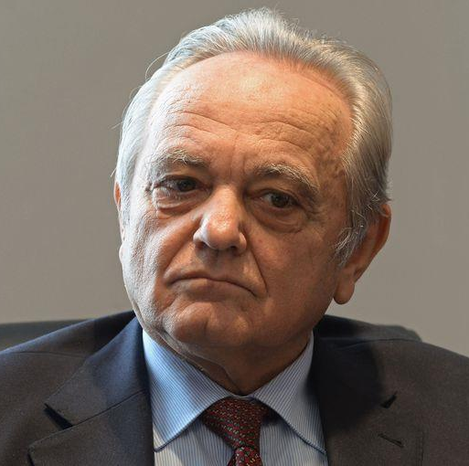
Mario Deaglio
Emeritus Professor of International Economics, University of Turin

Mario Deaglio is Professor Emeritus of International Economics at the University of Turin, Italy and Head of Economic Research at the Centro Einaudi, an independent Italian research institution.
His scientific work has mainly focused on structural problems of modern developed economies with a special interest for income distribution, the “submerged” economic sector, and Schumpeterian "economic long cycles". He then concentrated on issues related to globalization. Since 1996 he edits, and largely writes, an annual Report on the Global Economy and Italy (Rapporto sull'economia globale e l'Italia http://www.centroeinaudi.it/rapporto-sull-economia-globale-e-l-italia.html). He has pursued a parallel career in economic and financial journalism. As a young graduate he worked at “The Economist” in London and after that was a correspondent from Italy for this paper for many years. He also wrote for “The Banker” and gave seminars on Italy for many years at the Royal College of Defense Studies in London. In Italy he has worked mainly – and is still working - as a columnist for La Stampa (the country’s third largest daily). In 1980-83 he temporarily left La Stampa (and the University) to become Editor-in-Chief of Il Sole 24 Ore, Italy’s main economic daily. Professor Deaglio is author and co-author of books, research studies, monographs and scientific articles.

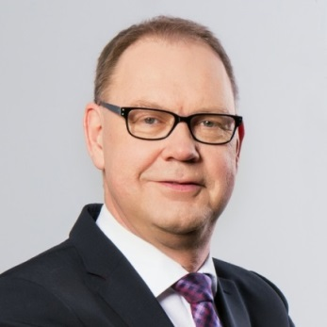
Aart De Geus
Chairman and CEO, Bertelsmann Stiftung, Gütersloh

Aart De Geus is Chairman and Chief Executive Officer of Bertelsmann Stiftung in Gütersloh. He has been a member of Bertelsmann Stiftung’s Executive Board since September 2011, overseeing projects on Europe, Employment, and Globalization. Prior to joining the Stiftung, Aart De Geus served as Deputy Secretary General of the Organisation for Economic Cooperation and Development (OECD) in Paris. From 2002 to 2007, Aart De Geus was Minister of Social Affairs and Employment in the Netherlands.

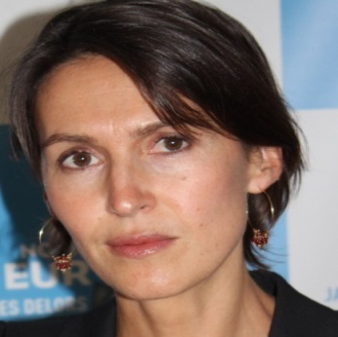
Elvire Fabry
Senior Research Fellow, Jacques Delors Institute, Paris

Dr Elvire Fabry is Senior Research Fellow at the Jacques Delors Institute (2009-). She is member of the editorial board of the international forecasting journal Futuribles and of the policy advisory committee of the European Movement - France. She is also co-founder and member of the advising committee of Proeuropa.
Her main fields of expertise are related to EU external policies and in particular trade policy. After being at the European Commission's Forward Studies Unit in 1995, she joined the prospective studies and foresight centre, Futuribles International. In 2003-04 she was research fellow at the Fondation Robert Schuman. From 2005 until spring 2009 she was director of the European programme at the Fondation pour l'Innovation Politique.
Elvire Fabry holds a PhD in political science (Sciences-Po Paris), and Master's degrees in philosophy and international relations (Panthéon Sorbonne - Paris I University). She was a member of the 64th session “Defence policy” at the Institute of Higher National Defence Studies (IHEDN) in 2011/2012. She is Colonel of the Reserve Citizen, French Air Force.

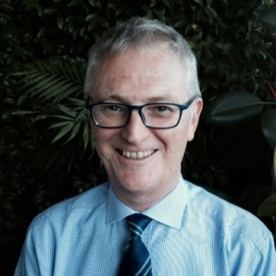
Maurizio Ferrera
Professor of Social Policy,University of Milan

Maurizio Ferrera is Professor of Political Science at the University of Milan. His main research interests are in the areas of comparative politics and policy analysis. He currently serves as President of the Network for the Advancement of Social Sciences (NASP) and member of the Board of Directors of the Centro di Ricerca e Documentazione Luigi Einaudi of Turin. Since 2004, he has been a regular columnist for the Corriere della Sera. His works have appeared on many international journals, including Comparative Political Studies, West European Politics, the Journal of Common Market Studies, the Journal of European Social Policy. His last book in English is The Boundaries of Welfare (Oxford University Press, 2005, French translation in 2009); in Italian he has recently published ‘Rotta di collisione. Euro contro welfare?’ (Laterza, 2016). In 2013 he has received an Advanced Grant by the ERC, to carry out a five-year project on “Reconciling Economic and Social Europe”.

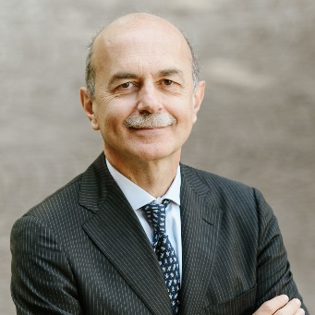
Piero Gastaldo
Secretary General, Compagnia di San Paolo, Turin

Piero Gastaldo has had a rich career in the foundation sector in Italy and Europe. Between 1979 and 1995 he held the position of Program Officer, Program Manager and later Director of Research at the Fondazione Giovanni Agnelli. He then took up the position of Assessore (Commissioner/Deputy-mayor) of the City of Turin, for Economic Development, Public Utilities, European Projects and International Promotion. In 1998 Mr. Gastaldo joined the Compagnia di San Paolo as the Director of Programs. Since 2001 he has held the position of Secretary General (CEO) at the Compagnia di San Paolo. In the same years Mr. Gastaldo has also been teaching and lecturing at several academic institutions. He is or has been active in the Boards of several non-profit institutions, at the national and the European level (among which the European Cultural Foundation, Amsterdam, and the European Foundation Center, Brussels) while he has been engaged in the financial sector as a Board member of Sinloc s.p.a., Fondaco SGR and the Cassa Depositi e Prestiti. Currently, Mr. Gastaldo is Member of the Governing Board of the Istituto Affari Internazionali, Rome; Member of the Governing Council of EFC, European Foundation Center, Bruxelles; Member of the Governing Board of the Fondazione Torino Musei; Member of the Governing Board of the Fondazione per il Libro, la Musica e la Cultura; Member of the Governing Board of the Fondazione Collegio Carlo Alberto. Piero Gastaldo graduated Summa Cum Laude from the Università degli Studi di Torino, Law School.

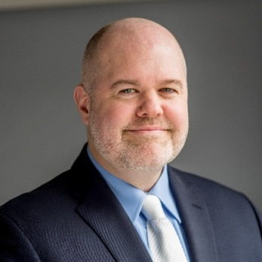
Christopher Hartwell
President, CASE – Center for Social and Economic Research, Warsaw

Christopher Hartwell (PhD) has over 20 years of experience in research projects and technical assistance throughout Europe, the transition countries of Central and Eastern Europe, the former Soviet Union, and Asia-Pacific. Currently President of the Center for Social and Economic Research (CASE) in Warsaw, he leads their work in the area of growth and trade, with an emphasis on trade liberalization, free trade agreements, and quantification of non-tariff barriers (NTBs). Through his work with CASE, he has participated in several framework contracts related to trade, including with the European Parliament’s INTA Committee and with DG Trade. He helped to design a new methodology for quantifying the costs of NTBs between Ukraine and the EU for a DG Trade project, subsequently published in Applied Economics Letters, and also authored for INTA a study on overlapping free trade agreements in the EU. Dr. Hartwell was also an expert on a recent DG Trade project examining the effects of a revised EU-Chile Association Agreement, contributing to the analysis on trade, investment, and public procurement effects. Prior to joining CASE, he was Head of Global Markets and Institutional Research at the Institute for Emerging Market Studies (IEMS) at the Moscow School of Management – SKOLKOVO, where he advised the Deputy Prime Minister of Kazakhstan on the trade and fiscal aspects of greater Eurasian integration. He continues to work on the trade-related facets of the Eurasian Economic Union, working closely with counterparts in Kazakhstan to help push for greater liberalization. Dr Hartwell also has spent years working on development assistance programs both with USAID and as an employee of the World Bank Group. He holds a PhD from the Warsaw School of Economics and a master’s in public policy from Harvard’s Kennedy School and is the author of Institutional Barriers in the Transition to Market: Examining Performance and Divergence in Transition Economies (Palgrave Macmillan, 2013) and Two Roads Diverge: The Transition Experience of Poland and Ukraine (Cambridge University Press, 2016). He has also published in prestigious journals such as JCMS – Journal of Common Market Studies, Regional Studies, Journal of Institutional Economics, and Journal of Economic Policy Reform.

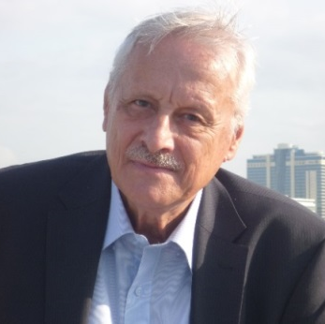
András Inotai
Research Professor, Institute of World Economics, Centre for Economic and Regional Studies, Hungarian Academy of Sciences Research, Budapest

András Inotai, professor emeritus at the Institute for World Economy, director general of the same institute between 1991 and 2011. Visiting professor at the College of Europe (Bruges and Warsaw), Center for European Integration (University of Bonn, Germany), European Online Academy (Berlin and Nice). Member of various international scientific/advisory boards (Progressive Economic Initiative and TEPSA in Brussels, College of Europe, Bertelsmann Foundation) and member of the editorial board of more than a dozen international professional journals. His main research areas include economic impacts of globalization, economic security issues, European integration with special regard to enlargement processes and experience of the new member countries.

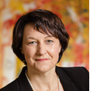
Marion Jansen
Chief Economist, International Trade Centre, Geneva

Marion Jansen is the Chief Economist of ITC and in this position responsible for the ITC’s flagship publication “SME Competitiveness Outlook” and ITC’s portfolios for export strategies and trade in services. She previously held senior positions in the World Trade Organization (WTO) and the International Labor Office (ILO). She worked in the private sector before joining the WTO.
Her publications in the field of international trade and global governance cover the areas of standards and regulations in international trade, the employment effects of globalization, services trade and economic effects of migration. She is one of the editors of the volume “The Use of Economics in International Trade and Investment Disputes” published by Cambridge University Press in April 2017.
Marion holds a PhD in economics from the Universitat Pompeu Fabra (Barcelona, Spain) and has lectured in different academic institutions on international economics, managerial economics and on the socio-economic impacts of globalization.

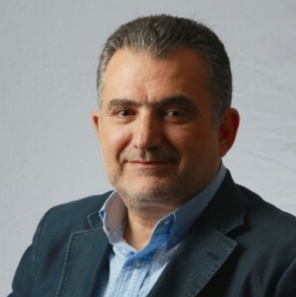
Salam Kawakibi
Deputy Director and Research Director in Arab Reform Initiative – ARI, France

Salam Kawakibi is the President of Initiative for a New Syria, President of board trusties of Ettijahat – Independent culture (www.ettijahat.org), board member of The Day After association (www.tda-sy.org), Senior Fellow with the Centre for Syrian Studies at the University of St Andrews, non-resident fellow with the Rafik Hariri Center for the Middle East at the Atlantic Council and a member of the Consultative Council of the Mediterranean Citizens’ Assembly (www.acimedit.net). Mr. Kawakibi is also a member of the Advisory Committee of the UNU Institute on Globalization, Culture and Mobility (UNU-GCM). He teaches in the Masters programme on Development and Migration at Université Paris 1 Panthéon-Sorbonne. Between 2009 and 2011, he was principal researcher at the Faculty of Political Science of the University of Amsterdam and between 2000 and 2006, he was director of the Institut Français du Proche Orient (IFPO) in Aleppo, Syria. He holds a DEA in Political Sciences from l'Institut d’Etudes Politiques, Aix-En-Provence, a DEA in International Relations from Aleppo University and a BA in Economy from Aleppo University.

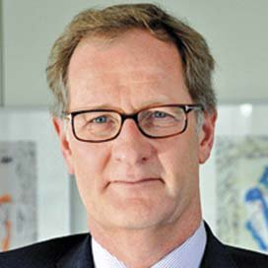
Joost Korte
Deputy Director-General, European Commission DG Trade

Deputy Director-General in DG Trade, European Commission Joost Korte was appointed Deputy Director-General of the European Commission’s Trade Department on January 1, 2017. Previously, the Dutch national served as Deputy Director-General in the Agriculture and Rural Development Department as well as in the Enlargement Department. Furthermore, Mr. Korte spent several years in the Commission’s Secretariat General as Director responsible for the relations with the Council of Ministers and gained extensive experience in the Private offices of Sir Leon Brittan, Chris Patten and Danuta Hübner. These professional experiences within the European institutions allowed him to develop a profound understanding of EU decision-making.
A lawyer by training, Joost Korte joined the Commission in 1991, following eight years of academic work on European law at the Universities of Utrecht and Edinburgh.

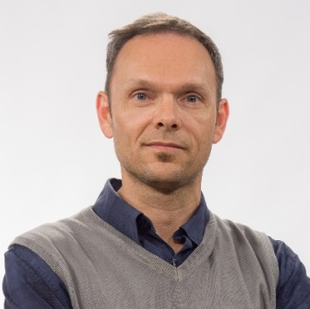
Marco Lisi
Professor, New University of Lisbon

Marco Lisi is an assistant professor in the Department of Political Studies, Nova University of Lisbon and researcher at IPRI-Nova. His research interests focus on political parties, electoral behaviour, democratic theory and political representation. He published several articles in national and international journals such as International Political Science Review, Comparative European Politics and Party Politics, among others. He coordinated several national projects and collaborated with a variety of international projects, such as ‘The Choice for Europe after Maastricht’ (University of Salzburg). Currently, he is the principal investigator of the project ‘From Representation to Legitimacy: Political Parties and Interest Groups in Southern Europe’, funded by the Portuguese Foundation for Science and Technology.

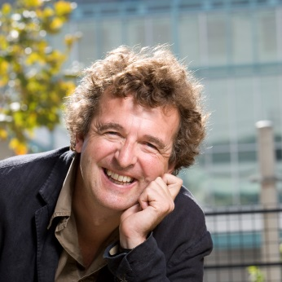
Ugo Mattei
Professor University of Turin and University of California, Hastings College of the Law

Ugo Mattei is Alfred and Hannah Fromm Professor in International Law at the University of California, Hastings College of the Law, and Professor of Civil Law at the University of Turin. Previously, he was Professor at the University of Trento, recipient of a call by the European University Institute in Fiesole, Visiting Professor at Montpellier University, Berkeley, and Macau and Visiting Scholar at Yale University and at Cambridge.
He serves advisory roles in many academic institutions including: the Fribourg Institute of Comparative Law, the Austrian and the Romanian Societies of Comparative Law and the Institute of Law, Economics and Finances at Copenhagen Business School. In addition, he is a member of the International Academy of Comparative Law, Editor-in-Chief of Global Jurist, editorial board member of the International Revue of Law and Economics and the Rivista Critica del Diritto Privato [Critical Review of Private Law], as well as former board member of the American Journal of Comparative Law.
Beyond his academic work, he has also been a prominent advocate of many Italian struggles for the reclamation of the commons. He was amongst the drafters of a landslide referendum that reversed water privatization in Italy, as well as serving as a consultant to the endeavor of collective self-management of the Teatro Valle, in the heart of Rome, and was President of Acqua Bene Comune (ABC) Napoli, the largest experiment of a re-publicized water board in Italy, in the city of Naples.
Professor Mattei’s work is highly interdisciplinary. He has published eighteen books and more than one hundred other publications in English, Italian, French, Spanish, Portuguese, Russian, Chinese, Japanese, and Ukrainian. Among his works are both influential academic monographs on comparative law, international law and legal theory, alongside a number of books for the general public, which criticize the public role of the law, and argue for its re-orientation towards the paradigm of the commons.

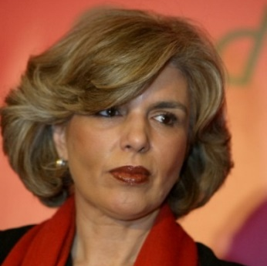
Isabel Mota
President, Calouste Gulbenkian Foundation, Lisbon

President of the Board of Trustees of the Calouste Gulbenkian Foundation and President of the Supervisory Board of Partex Holding BV, since May 2017. From 1999 until 2017, Mrs. Isabel Mota was Member of the Calouste Gulbenkian Foundation Board of Trustees. She is non executive member of the board of Santander-Totta Bank, since July 2015.
Graduated in Finance from the University of Lisbon (1973), Mrs. Mota acted as Assistant Lecturer at the Higher Institute of Economics from 1973 until 1975. She then became general sub-director in the Office for External Economic Cooperation, of the Ministry of Finance, from 1978 until 1986 and subsequently Councillor to the Permanent Representative of Portugal to Brussels in 1986. From 1987 until 1995, she served as Secretary of State for Planning and Regional Development in the 11th and 12th Constitutional Governments with responsibility for negotiations over European Union Structural and Cohesion Funds for Portugal. She became the Director of the Executive Training Institute for Nova University of Lisbon in 1977 and a member of the Telecel Vodafone General Council in 2001, until 2003. In 2004, she coordinated the drafting of the National Strategy for Sustainable Development.
Mrs. Mota is currently member of the Prize Juries of the Jacques Delors Award and COTEC-BPI Innovation. She also served as an advisor to the Economic and Social Council of Portugal (until 2016) and was a member of the Portuguese Honorific Orders Council (since 2011).
In 2006, Mrs. Isabel Mota received the commendation of the Grand Cross of the Order of Infante D. Henrique, Portugal.

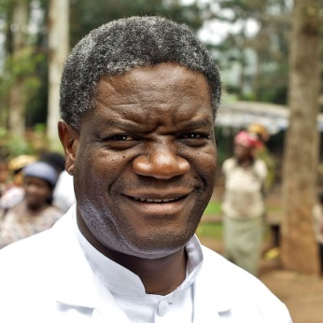
Denis Mukwege
Mukwege Foundation, Switzerland

Dr Denis Mukwege, born on 1 March 1955, is a world-renowned gynaecological surgeon as well as the founder and medical director of Panzi Hospital in Bukavu, Democratic Republic of the Congo (DRC). After having studied in France, he established the hospital in 1999 as a clinic for gynaecological and obstetric care, as he expected to primarily work on maternal health.
Immediately after the opening of the hospital, Dr Mukwege noticed the high number of women in the region who needed treatment of their wounds caused by violent sexual assault and rape. His first patient was a survivor of rape whose reproductive organs had been destroyed.
Over the years Dr Mukwege became the world's leading expert on “repairing” the internal physical damage caused by rape.
In October 2012, he was violently attacked and his family was held at gunpoint at his home in an assassination attempt. Joseph Bizimana, his friend and security guard, was killed. The attack came several weeks after a speech at the United Nations where Dr Mukwege denounced the country’s decade-long conflict and called for those responsible to be brought to justice.
Dr Mukwege and his family fled to Europe for a short period of time. Despite continuous threats against him, he returned to Eastern Congo in January 2013 and resumed his work at the hospital, responding to the call from the women of Bukavu.
Dr Mukwege has become a global advocate for gender equality and the elimination of rape as a weapon of war. He received numerous international awards for his work, including the UN Human Rights Prize, the Sakharov Prize of the European Parliament, the Olof Palme Prize, the Calouste Gulbenkian Prize 2015 and the Clinton Global Citizen Award. TIME magazine listed him among the world's 100 most influential persons and the Carter Foundation named him a “citizen of the world.”

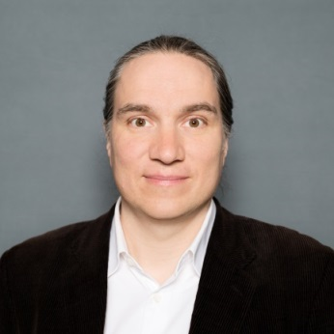
Aleksi Neuvonen
Demos Helsinki

Aleksi Neuvonen is the co-founder of the Nordic think tank Demos Helsinki. He is a futures researcher and an expert on urban development and lifestyle changes, with a twenty-year career in multi-disciplinary social research.
Currently Aleksi Neuvonen is in charge of Demos Helsinki’s research activities and leads co-creation activities in several academic research consortia. He is also working on a book on societal visions of the post-industrial transformation in The Next Era initiative.
In the past Aleksi’s work with VTT technology research group and the Turku School of Economics Futures Research Centre gave him a thorough introduction to major systemic social entities, such as innovations policy, global sustainable development challenges and the economic importance of creative industries. He holds MA (philosophy) from University of Helsinki and is currently preparing his PhD in planning theory in Tampere University of Technology and Radboud University Nijmegen.

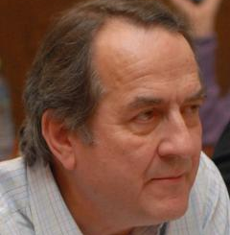
Quentin Peel
Associate Fellow, Chatham House, London

Quentin Peel is an associate fellow with the Europe Programme at Chatham House.
He joined the Financial Times in 1975. Between 1976 and 1994, he served successively as Southern Africa correspondent, Africa editor, European Community correspondent and Brussels bureau chief, Moscow correspondent, and chief correspondent in Germany.
He was also foreign editor and international affairs editor from 1994 until 2010, and finally chief correspondent in Berlin until 2013. Quentin joined Chatham House in 2014.
He was educated at Queens' College, Cambridge, where he read Economics with French and German.

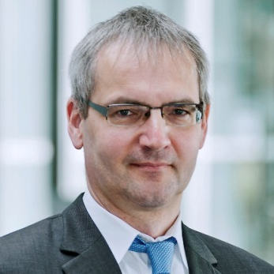
Thiess Petersen
Senior Advisor, Bertelsmann Stiftung, Gütersloh

Thiess Petersen joined the Bertelsmann Stiftung in 2004 and specializes on macroeconomic studies and economics. He studied economics in Paderborn and Kiel before joining the Institute for Theoretical Economics at Christian-Albrechts-University in Kiel as a research assistant. He then became a research assistant and lecturer in economics at the University of Applied Sciences in Heide. After that he was a project adviser with at the DAG Forum Schleswig-Holstein in Kiel, later becoming the forum’s managing director. In addition to his work for the Bertelsmann Stiftung, he is a lecturer at the European University Viadrina in Frankfurt (Oder), where he specializes in macroeconomics, economic growth and public finance.

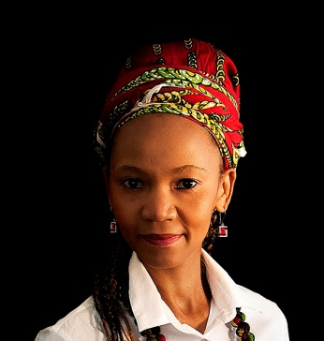
Liepollo Lebohang Pheko
Senior Research Fellow at Trade Collective, Africa, Coordinator of the INMD, Member of the Action Research Network for WE-Africa, South Africa

Lebohang Liepollo Pheko is an activist scholar, researcher , public intellectual, development practitioner.
Ms Pheko's interests lie in Afrikan political economy, States& nationhood, international trade & global financial governance, feminisation of poverty, regional integration and impacts of globalisation on labour migration. Senior Research Fellow at research and policy advocacy think tank - Trade Collective and has taught Collective and has taught International Trade and developed a course on Afrikan Feminism the Thabo Mbeki African Leadership Institute where she is a founding faculty member and Associate in addition to academic institutions in Sweden,Norway,UK, US , Kenya and Mexico. She has followed global discourses on international trade and labour implications of migration at the WTO, the UN and now the Global Compact on Migration. She has co-authored and contributed to several books and academic journals on these and related issues.

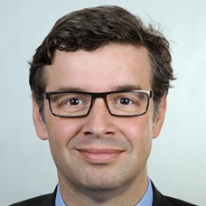
Stefan Profit
Deputy Director-General Macroeconomic Development, Analysis and Projections, Federal Ministry for Economic Affairs and Energy, Berlin

Stefan Profit holds the position of a Deputy Director General in the Economic Policy Department of the German Federal Ministry of Economic Affairs and Energy. His directorate deals with macroeconomic developments, economic analysis, research and projections. Before assuming this position, he led a ministerial unit focusing on the empirical research in the field of inclusive growth, productivity and investment, as well as assessing growth and distributional effects of structural reforms. During previous assignments in various ministries, he worked in the field of labor market reform and energy policy, foreign economic affairs, policy planning, and served as a personal advisor to the Minister. Previous to his engagement within the federal government he worked for the Bertelsmann Foundation. He has an academic background in labor economics holding an Economics diploma from the University of Bonn and doctoral degree in Economics from Humboldt University Berlin.

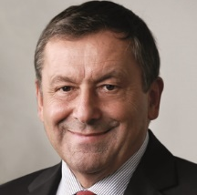
Francesco Profumo
Chair, Compagnia di San Paolo

Born in Savona in 1953. Degree in Electrical Engineer - Politecnico Torino.
Professor of Electrical Machines of the Politecnico Torino, former Dean of Engineering at the Politecnico Torino, former Rector of the Polytechnic Turin, former President of the National Research Council, former Minister of Education, University and Research, former Chairman of Iren SpA, Chairman of Compagnia di San Paolo, Chairman of Fondazione Bruno Kessler (Trento), President of Business School ESCP - Campus of Turin, President of Collège des Ingégenieurs - Campus of Turin, Chairman of Inwit SpA.

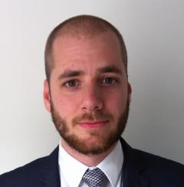
Thomas Raines
Research Fellow and Program Manager Europe Programme, Chatham House, London

Thomas Raines is a research fellow at Chatham House, where he manages the Europe Programme. Previously, he worked in the Strategy Unit of the Foreign & Commonwealth Office in London. His research interests lie in the UK’s relationship with the EU, British foreign policy, and public attitudes to international affairs. He is the author of a number of Chatham House research papers, including The Future of Europe: Comparing Public and Elites Attitudes, with Matthew Goodwin and David Cutts (2017); Internationalism or Isolationism? British Attitudes Towards the UK’s International Priorities (2015); Europe’s Energy Union (2016), with Shane Tomlinson; and UK Unplugged? The Impacts of Brexit on Energy and Climate Policy (2016), with Antony Froggatt and Shane Tomlinson.

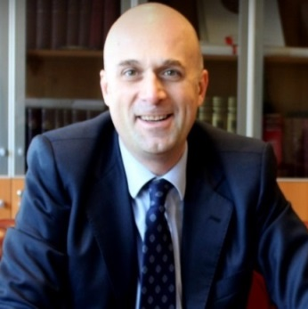
Stefano Sacchi
University of Milan, and President National Institute for the Analysis of Public Policies (INAPP), Rome

Stefano Sacchi is President of the new Italian National Institute of Public Policy Analysis (INAPP). He is also Associate Professor of Political Science at the University of Milan, where he teaches Comparative Political Economy and Adjunct Professor at LUISS University in Rome, where he teaches Welfare and Labor Policy. From 2014 to 2016, during the Renzi Government, he was a special adviser to the Italian Labor Minister and then to the Prime Minister’s office. As the special adviser to the Italian Labor Minister, he designed and drafted the reforms of Italian unemployment benefits and short-time work in the context of Italy’s 2015 labor market reform (so-called Jobs Act). He has authored or co-authored more than fifty academic publications in the field of comparative social and labor policy, and was visiting scholar or lectured in several universities worldwide, including Cornell, Princeton, Toronto, NYU, University of Washington, Tokyo University and Waseda.

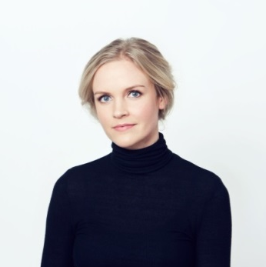
Aura Salla
Adviser for Communication and Outreach, European Political Strategy Centre, European Commission, Brussels

Aura Salla was previously working as a Member of Cabinet and Communications Adviser of Jyrki Katainen, European Commission Vice President responsible for Jobs, Growth, Investment and Competitiveness. She joined Mr Katainen's team in August 2014.
Before joining the Commission she worked in a consultancy firm Recommended Finland as a Project Manager specialising in EU Affairs and Communications and before that as a speechwriter in the Finnish Parliament.
Aura has been visiting lecturer in Harvard University. She holds a Master's degree in Political Science from the University of Turku Finland and she has also studied Economics of the European Union in University of Leipzig, Germany.

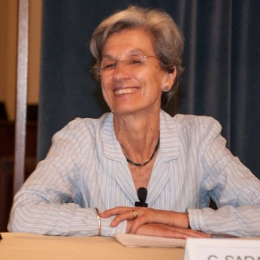
Chiara Saraceno
Honorary Fellow, Collegio Carlo Alberto, Turin

Chiara Saraceno, former Professor of Sociology at the University of Turin and Research Professor at the WZB in Berlin, is presently honorary fellow at the Collegio Carlo Alberto, Turin and Emerita at the WZB. Her research topics, often from a comparative perspective, concern welfare arrangements, poverty, changing families, gender relations. She has been a member of the Italian Poverty Commission for many years, chairing it in 2009-2001. Since 2013, she is a member of the High Level Expert Group on the Measurment of Economic Performance and Social Progress (HLEG).
Among her recent publications: (with L. Natali) “The impact of the great depression on child poverty. The case of Italy”, in B. Cantillon, Y. Chzhen, S. Handa (eds), Children of Austerity, Unicef/Oxford University Press, 2017; Varieties of Familialism. Comparing Four Southern European and East Asian Welfare Regimes.Journal of European Social Policy, 26 (4), 2017; L’equivoco della famiglia, Laterza, 2017; Mamme e papà, Gli esami non finiscono mai, il Mulino, 2016; Il lavoro non basta. La povertà in Europa negli anni della crisi, Feltrinelli, 2015; Saraceno, Chiara, il Welfare, il Mulino, 2013; “Trends and tensions within the Italian family”, in The Oxford Handbook of Italian Politics (E. Jones and G. Pasquino eds), OUP, 2015.

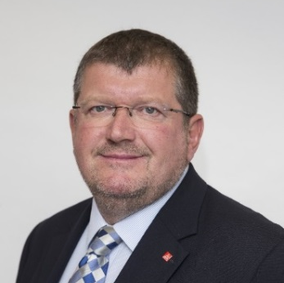
Peter Scherrer
Deputy General Secretary, European Trade Union Confederation, Brussels

Peter Scherrer was elected as Deputy Secretary General of the ETUC at the Paris Congress in 2015. He takes the institutional lead on European Social Dialogue and is also responsible for relations with employers’ organisations, Workers’ Participation, European Works Councils and Industrial Policy. He has held many trade union positions previously including general secretary of the European Metalworkers Federation (2005 – 2011). From 1998-2002 he was Editor-in-Chief of the South-East Europe Review for Labour and Social Affairs (SEER).

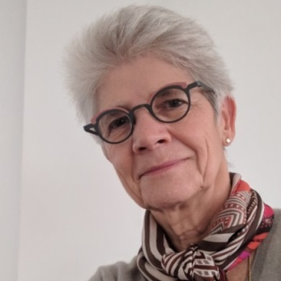
Bernadette Ségol
Former Secretary General of the European Trade Union Confederation, Brussels

Bernadette Ségol grew up and was educated in the South-West of France. Her professional life was dedicated to the international and soon after European trade union movement, combining a pro-European stance with social commitments. In 2001 she became Regional Secretary of UNI-Europa, the European trade union organisation for private services. In 2011 she was elected General Secretary of the European Trade Union Confederation. She retired at the 2015 Congress. She holds a master degree in Philosophy.

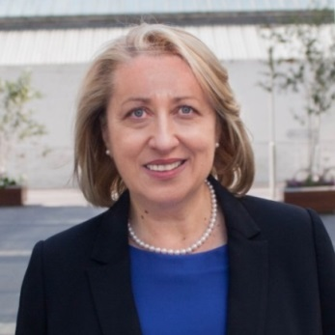
Iulia Siedschlag
Associated Research Professor Economic and Social Research Institute Trinity College Dublin

Dr Iulia Siedschlag is Associate Research Professor at the Economic and Social Research Institute (ESRI) and Adjunct Professor at the Department of Economics, Trinity College Dublin. She leads the ESRI’s research on Internationalisation and Competitiveness. Iulia has published widely in peer reviewed international journals and books, especially on international trade, foreign direct investment, innovation, productivity and economic growth in Ireland and European Union countries. She has been awarded a significant number of research grants from international and national organisations and has successfully led a large number of international research consortia involving research institutes and universities from Europe. Iulia has been appointed to numerous Expert Groups and provided policy advice to national and international organisations including the European Commission, the European Central Bank, the World Bank, the Inter-American Development Bank, the Asian Development Bank Institute, the International Labour Organization, and the World Economic Forum.

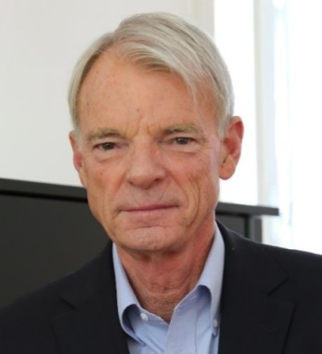
Michael Spence
Professor of Economics, New York University

Served as the Chairman of an Independent Commission on the Growth in Developing Countires (2006-2010 – the life of the commission). He is professor of Economics at the Stern School at NYU, Proessor Emeritus of Management in the Graduate School of Business at Stanford University, a Senior Fellow of the Hoover Institution at Stanford and Professor of Economics at the Stern School of Business at New York University. Seonce received the Nobel Prize in Economic Science in 2001, and the John Bates Clarck Medalin 1982, for work on markets with asymmetrical information. He is the author of the book “The Next Governance: The Future of Economic Growth in a Multispeed World”, Ferrar, Straus and Giroux, May 2011. His current research and teaching focus mainly on growth patterns and policies in a wide range of developed and developing countries. He served as Dean of the Stanford Business School from 1990 to 1999. As Dean, he oversaw the finances, organization, and educational policies of the school. He served as Dean of the Faculty of Arts and Sciences at Harvard from 1984 to 1990. He is a Senior Advisor to Oak Hill Investement Management, and a consultant to PIMCO. He is the co-chair of the Advisory Board of the Asia Global Insitute, based in Hong Kong. He is a member of the Advisory Board of the School of Economics and Management of Tsinghua University. Spence writes monthly columns for Project Syndacate which are published globally (Spence in Project Syndacate).

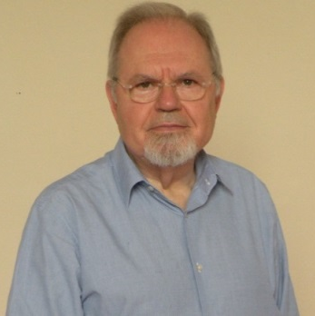
Pietro Terna
President, Collegio Carlo Alberto

Pietro Terna is a retired professor of the University of Torino (Italy), where he was a full professor of Economics he is currently the president of the Collegio Carlo Alberto, www.carloalberto.org. His research work is in the fields of (i) artificial neural networks for economic applications, (ii) social simulation with agent-based models (where he has been pioneering the use of Swarm, www.swarm.org), and (iii) simulation of enterprises and organizations behavior, also in the financial domain, with studies on systemic risks with co-authors of the Italian Central Bank. He has prepared a new agent-based simulation tool in Python (Swarm-Like Agent Protocol in Python), SLAPP, deriving it from the Swarm project, at https://github.com/terna/SLAPP/. He is teaching a course of Econophysics in the Master Degree in Physics for Complex Systems of the University of Torino. Publications and projects at http://terna.to.it.

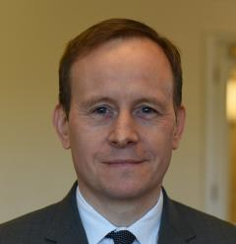
Adam Ward
Deputy Director, Chatham House, London

Adam Ward became deputy director of Chatham House in April 2017. He was previously, from 2009, director of studies of the International Institute for Strategic Studies (IISS), where his earlier assignments included serving for four years as executive director of the IISS US office in Washington DC, and as senior fellow for East Asian security. He began his career at the consulting firm Oxford Analytica. Adam received his BA and MA from Warwick University.

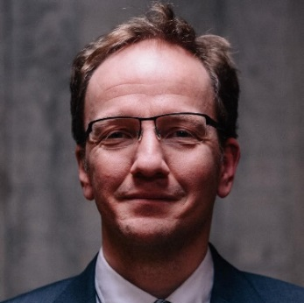
Guntram Wolff
Director, Bruegel, Brussels

Guntram Wolff’s research focuses on the European economy and governance, on fiscal and monetary policy and global finance. He regularly testifies to the European Finance Ministers' ECOFIN meeting, the European Parliament, the German Parliament (Bundestag) and the French Parliament (Assemblée Nationale). From 2012-16, he was a member of the French prime minister's Conseil d'Analyse Economique. Guntram Wolff is also a member of the Solvay Brussels School's international advisory board of the Brussels Free University. He joined Bruegel from the European Commission, where he worked on the macroeconomics of the euro area and the reform of euro area governance. Prior to joining the Commission, he was coordinating the research team on fiscal policy at Deutsche Bundesbank. He also worked as an adviser to the International Monetary Fund.
He holds a PhD. from the University of Bonn; he studied economics at the Universities of Bonn, Toulouse, Pittsburgh and Passau, and he taught economics at the University of Pittsburgh. He published a number of articles in various acclaimed economic journals.

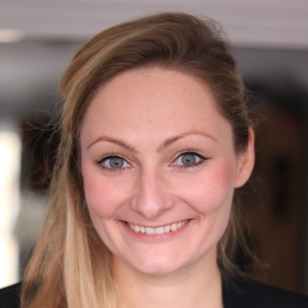
Linda Zeilina
Advisor and Head of Future Europe Program Re-Define, London

Linda Zeilina is a Special Advisor at Re-Define and runs its Programme on the Future of Europe. She is also a Fellow of the Royal Society of Arts.
She has previously worked as an Advisor and speechwriter for a number of prominent policymakers in Europe, and for several years she actively participated in the European Youth Parliament network in a variety of roles. Lately, her work has focused on the changing landscape of political economy, Brexit and the importance of sustainability in business and investing. Linda has also written for a range of publications, including Politico and EUObserver.
Linda holds a degree from the London School of Economics, where she ran a number of student-led initiatives at the European Institute. She is also an alumna of McGill University and the University of Glasgow.

