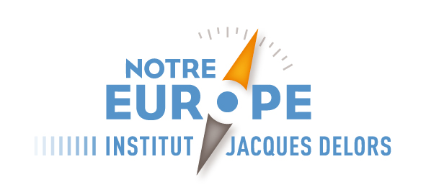

Yves Bertoncini
Biography
Director of Notre Europe – Jacques Delors Institut
|||||||||||||||||||||||||||||||||||||||||||||||||||||||||||||||||||||||||||||||||||||||||||||||||||||||||||||||||||||||||||||||||||||||||||||||||||||||||||||||||

Yves Bertoncini is director of Notre Europe - Jacques Delors Institute since April 2011.
He succeeded to Gaëtane Ricard-Nihoul, Jean Nestor et Christine Verger.
He assists the president in his activities, directs the team and is responsible for managing the work programme. He also takes part in Notre Europe-Jacques Delors Institute’s research work, focusing in particular on questions of European policy and institutions and on issues relating to democracy and mobility.
Yves Bertoncini is an adminstrator at the European Commission, where he has worked at the Directorates-General “Education, Training, Youth” and “Regional Policy”.
He has worked in the office of the French prime minister with responsibility for research on Europe at the Centre d’Analyse Stratégique (2006-09), and as adviser to the secretary-general of European affairs. He has also worked for the French minister of foreign and European affairs, on the organisation of the “national dialogue for Europe” (1995-1997) and at the French embassy in Algiers (1992-93). He was responsible for international affairs at the Fédération Française des Sociétés d’Assurance (2002-05).
He teaches or has taught European issues at the Corps des Mines (Mines Paris Tech), at the Institut d’Études Politiques (IEP) in Paris (2001-11) and at the École Nationale d’Administration (2007-09). He is the author of numerous books articles and policy papers on European questions.
Yves Bertoncini holds degrees from the Institut d’Études Politiques in Grenoble and the College of Europe in Bruges. He has also studied at the IEP Paris and at the University of California in Berkeley.

He was born on 30 March 1970 in Chambéry and is married with three children.
19 rue de Milan 75009 Paris – France
T +33 (0)1 44 58 97 97 – F +33 (0)1 44 58 97 99
www.notre-europe.eu

