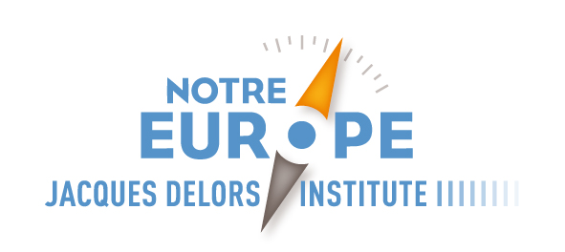

List of donors to the Jacques Delors Institute
for the Year 2015 (as of 20 November)

Jean-Yves Archer
Stéphanie Baz
Yves Bertoncini
Julie De Bonneval
Eric Deloire
Jacques Delors
Jean-Hugues Duban
Fredrik Erixon
Jonathan Faull
Sacred (Didier Fegly)
Charles Fitermann
Françoise Harraca de Trenqualye
Clive Hole
Jan Kurlemann
Eneko Landaburu
Didier Legros
Pierre Lepetit
Christophe Lescot
Vitor Martins
François Mennerat
Pierre Mirel
Riccardo Perissich
Pascal Perrochon
Julian Priestley
Gaëtane Ricard-Nihoul
Michel Richonnier
George Ross
Dominique Thaury
Jean-Marie Triacca
Pieter Van Nuffel
Christine Verger
François Vié
Maurice Zylberberg

